ST. LUKE CATHOLIC CHURCH
FAMILY FAITH FORMATION
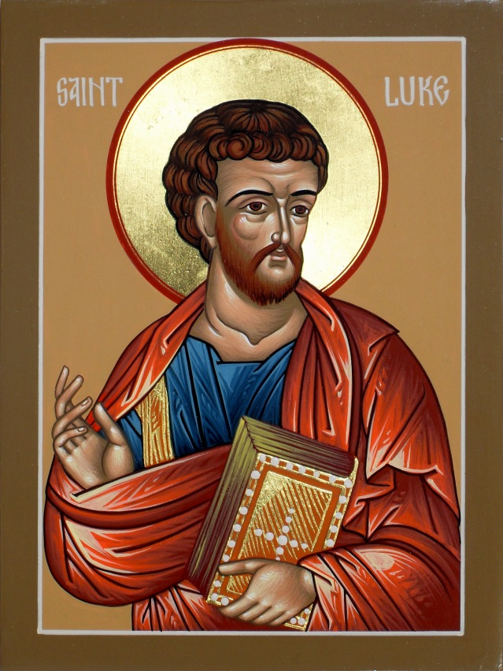
HANDBOOK

St. Luke Catholic Church
1606 Blanding Blvd
Middleburg, FL 32068
(904) 282-0439
www.stlukesparish.org

Contents
DIRECTORY 4
General Policies for All Formal Programs Involving Children 5
Diocese of St. Augustine Safe Environment Program 8
Safe Environment Policy: 9
Children & Youth Personal Safety Program 9
Introduction 9
Implementation 10
Program Materials 10
Record Keeping 10
Making the Safe Environment Happen: 10
Specific Requirements: 11
SACRAMENTAL PREPARATION 12
The Sacrament of Baptism 13
The Sacrament of First Reconciliation and Eucharist (FRFE) 14
The Sacrament of Confirmation 15
Rite of Christian Initiation of (Adults) Adapted for Children 17
FAMILY FAITH FORMATION PROCESS 19
Children’s Liturgy of the Word (CLOW) 21
Nursery 21
Vacation Bible School 22
Youth Faith Formation 22
Catholic Youth Ministry (CYM) 22
Faith Formation and Religious Education for Adults 23
Rite of Christian Initiation for Adults (RCIA) 23
Adult Confirmation: 25

Important: Please be sure to register as a Parishioner/Parish Family with the office before registering your family for Religious Education classes. If you are new to St. Luke’s Family Faith Formation Program and have attended classes at another parish, please attach a letter from your former parish that describes the program, text that was used, number of classes per year and your child’s attendance.
This handbook is intended to offer a general overview of all current/active programs offered by St. Luke Catholic Church. It is in no way intended to offer complete/exhaustive information and the Pastor of St. Luke Parish reserves the right to alter programs/policies/dates etc. as deemed necessary.

For the most up to date information please check our website:
www.stlukesparish.org

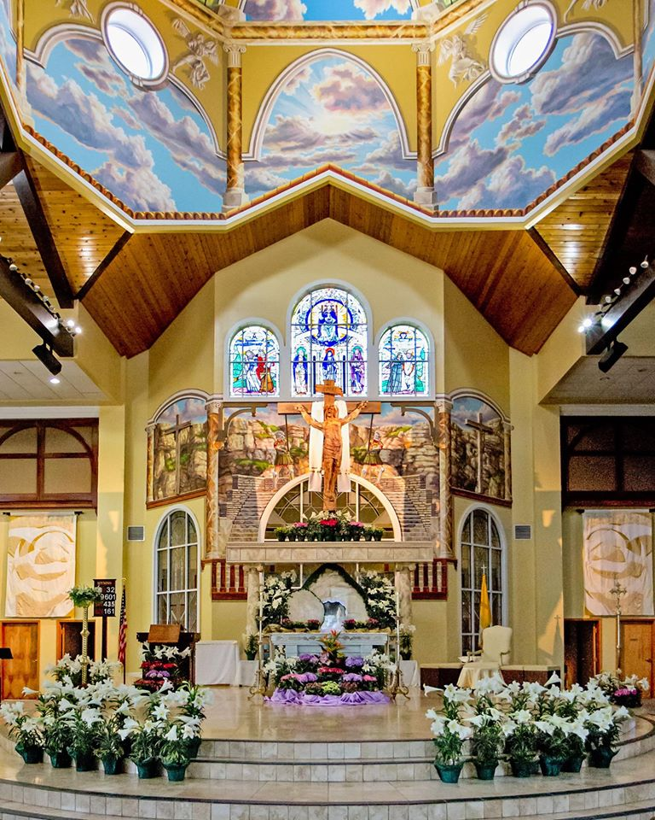

DIRECTORY

Office: 1606 Blanding Blvd, Middleburg, FL 32068
Phone: 904-282-0439
Fax: 904-291-9711
Website: www.stlukesparish.org

Rev. Andy Blaszkowski Pastor ext. 111
FrAndy@stlukesparish.org
Rev. Jaisemon Xaviour Director of Religious Education ext. 112
FrXaviour@stlukesparish.org
Deacon Steve Arnold Baptism Preparation ext. 111
baptsims@stlukesparish.org
Laura Austin Coordinator, Family Faith Formation ext. 112
laura@stlukesparish.org
Jon Ayres RCIA & RCIA-C Coordinator ext. 120 rcia@stlukesparish.org
Kathy Quigley RCIA & RCIA-C Assistant ext. 120
kathy@stlukeparish.org

General Policies for All Formal Programs Involving Children
Policies apply to all age groups unless otherwise noted
Mass Attendance:
Sunday worship is very important to our identity as Catholic Christians. It is where we, as a parish family, are nourished by God’s Word and the Sacrament. The Sunday Liturgy (Mass) is the gathering of the faithful to pray and give praise to God. During the Liturgy, we hear the Word of God proclaimed. The Homilist (priest or deacon) shares his thoughts on the Word, and we are to take the Word with us as we leave the Church. One way for us to truly live out the Word of God is to spend time reflecting on what these words mean to us.

It is expected that days of obligation are shared family events which take priority over other activities. Weekly Mass attendance provides an excellent hands-on opportunity to explain the Mass to your child as well as giving an opportunity for your child to understand and practice proper behavior during Mass. All students are expected to attend Sunday Mass weekly in order to grow in understanding of their Catholic Faith. Therefore, all students enrolled in the Family Faith Formation Process at St. Luke Catholic Church will be asked to complete a Mass reflection sheet once a month after attending a Sunday Liturgy.

Class Attendance:
Regular attendance is critical to the success of any faith formation program because child development and faith formation development is progressive (i.e., we need to know some things before we can understand other things). Students, first through eighth grade, are expected to attend all sessions, including Liturgies, celebrating of the Sacraments, family, and special Faith Formation events.

Attendance at the Family Faith Formation days is a requirement to participating in the Family Faith Formation Process at St. Luke Catholic Church. Due to the nature of these events, it is not possible to make up these sessions and every effort must be made by the family to attend. If you are unable to attend a Family Faith Formation Day, you may not be allowed to continue in the Family Faith Formation Process at St. Luke Catholic Church.
Students are expected to attend all scheduled classes. Absences should only be due to illness or family emergencies. If a student misses a class, make-up work is required. This work will be provided through the student’s catechist. Please have the student complete this work within two weeks.
Attendance records for Religious Education are in keeping with diocesan policies and help determine eligibility for the sacraments of First Confession, First Holy Eucharist, and Confirmation.
- 2 or more unexcused absences in any given year constitute excessive absenteeism.
If excessive absenteeism occurs in the year proceeding a “sacramental year” the child will be considered ineligible for immediate preparation for the sacrament.
- Absences may be excused due to illness, death, or family crisis. In such cases the Religious Education department must be notified to be considered excused.
- Missed work and or assignments must be completed and returned to the catechist.
- Students are expected to arrive to class on time.

In the instance of a child having more than one custodial home, please contact the Religious Education Office so that we can better serve your family’s needs.

Religious Education Visitors Policy:
If a child wishes to bring a visitor with him/her to class, the registered parent brings the visiting child to the media center and logs in with an emergency phone number and will receive a “visitor’s pass” to present to the catechist. The visiting child along with the registered student shall be escorted to and from the classroom by the parent.
Conduct:
Students are expected to participate in class activities and discussions. Life as a Christian is a commitment to live by the example of Jesus Christ. This includes accepting responsibility for conduct and actions, along with the commitment to respect others.
We use Annunciation Catholic School for most of our regularly scheduled classes. It is of utmost importance that all children and parents respect the exterior school property as well as the classrooms. It is of particular importance that your children understand that they will be sitting at desks used by day students and that the property contained within should not be played with, moved or taken.
Discipline:
The catechist will handle normal discipline problems. If a problem becomes persistent, the student will be sent to the Session Coordinator or the Director of Religious Education. A continuing problem may necessitate a call to the parents. A parent may be requested to attend class with a child in extreme cases and ultimately may be asked that the child discontinue in class participation for a period of time. In such a situation homeschooling is an option.
Behavior that will not be tolerated includes, but is not limited to, abusive language, fighting, vandalism, disrespect to the catechist or other students, stealing, and leaving the building during class time.
Dress:
Please ensure that your child is dressed in an appropriate manner. All dress should be modest, reflecting the intrinsic dignity of the human person, and not constitute a distraction to others.

Weather:
If Clay County Schools are closed for severe or inclement weather, classes will not be held. If you judge conditions in your area to be unsafe, please stay home. In all situations please err on the side of caution and safety.

Emergency Contacts:
If an emergency should arise during a class, you may reach the Religious Education Coordinator at 904-282-0439 ext. 112 or via email at laura@stlukesparish.org.

Special Needs:
Please let us know if there are any medical conditions, learning or physical needs which may affect your child’s learning experience. Our goal is to provide a positive, affirming atmosphere in which all students can learn and grow in their faith.

Communication:
Communication between parish and family is essential. We will communicate to you through various means:
- Fliers handed out at classes
- My Catholic Faith Delivered Platform
- Email
- Parish Bulletin
- Parish Website at www.stlukesparish.org
- Bulletin Board located in the church foyer
We also rely on you to keep us informed of important developments in your family life that affect our ability to serve you.
Safety:
The safety of your children is very important to us. To ensure the safety of your children we are continuing the following policy and ask that everyone please follow:
- All parents are required to park their cars in a designated parking spot and escort children to and from the classrooms.
- The fire lane is not to be blocked at any time.
- Respect the Handicap and reserved parking spaces.
- No Children should ever be unsupervised by parent/guardian prior to or after classes.
- Parent(s) should not leave a child in a classroom unattended by a catechist.

Diocese of St. Augustine Safe Environment Program
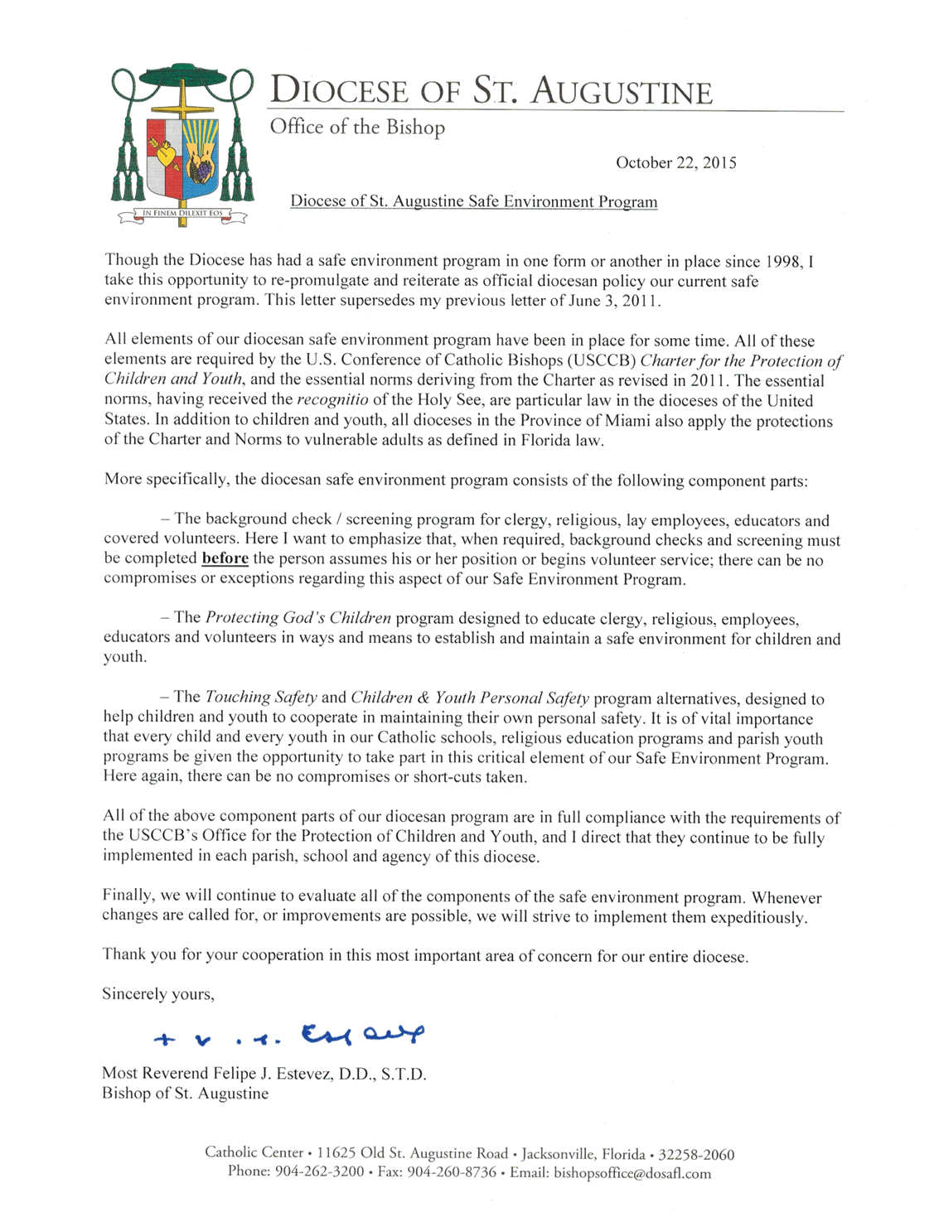

Safe Environment Policy:
The Safe Environment Program for the Diocese of St. Augustine has been in place in one form or another since 1998. All elements of our program are required by the United States Conference of Catholic Bishops’ Charter for the Protection of Children and Young People, and the essential norms deriving from the Charter. The essential norms, having received the recognition of the Holy See, are particular law in the dioceses of the United States.
In the Diocese of St. Augustine, the SAFETY education of children and youth is accomplished by way of one of the two following programs:
- Touching Safety Program (VIRTUS organization), or
- Children and Youth Personal Safety Program (adapted from the Diocese of Harrisburg’s Formation in Christian Chastity Program).
The Touching Safety Program lesson plans and the Children and Youth Personal Safety Program lesson plans are available on the Diocese of St. Augustine web site at http://www.dosafl.com, click on the Safe Environment Programs link at the bottom of the home page.
Either the Touching Safety Program or the Children & Youth Personal Safety Program is a mandatory part of each parish religious education and youth program for children and youth who do not attend Catholic schools. One or the other program is also a required part of the curriculum in all Catholic schools in the diocese. A parish or school may implement either of these programs.
PLEASE NOTE: St. Luke’s Parish uses the children and youth Personal Safety Program
As the Children & Youth Personal Safety Program focuses strictly on personal safety within the context of Catholic moral theology, there is no opt-out provision for this program. It is an integral part of the doctrinal and moral teachings of the faith.

Children & Youth Personal Safety Program

Introduction
The Charter for the Protection of Children and Young People, adopted by the United States Conference of Catholic Bishops in 2002, requires the parish or school to provide formation for the children in the areas of safety and integrity of their person. Our philosophy is to directly involve parents in the formation of their children. In addition to a classroom presentation of safety issues, adapted for different grade levels, parents will receive materials to help guide their own discussions with their children.
This program accomplishes these goals in two ways:
- Parents will receive materials on teaching children about the issues of safety. They will take the form of two information sheets from a nationally recognized center on child safety, along with additional materials incorporated into the parent’s letters.
- Lesson plans are included with this program that teaches children their role in maintaining a safe environment. The lesson plans are arranged for younger children, older elementary students and high school students.

Implementation
During the initial year that this program is implemented in a parish religious education or youth program, or in a Catholic school, all children and young people in every grade levels will receive the classroom instruction (one lesson plan), and all parents will receive the safety information (letters to parents and attachments). In subsequent years, the primary level lesson is directed only to students in 1st and 3rd grades, the intermediate level lesson is directed only to students in 5th and 7th grades, and the high school level lesson is only for students in 9th and 11th grades. Information and letters sent to Parents will also follow this same pattern.

Program Materials
- Information sheets: “Know the Rules” and “Questions and Answers” (in both English and Spanish)
- Primary Grades (1-4): Lesson plan for religious education program or school, and sample Patent letter (to include info sheets as attachments)
- Intermediate Grades (5-8): Lesson plan for religious education program or school, and sample Parent letter (to include info sheets as attachments)
- High School: Lesson plan for religious education program, youth program or school, and sample Parent letter ( to include info sheets as attachments)

Record Keeping
Except for keeping a record of the dates on which these lesson plans are taught, there is no other record keeping involved.
*The information is available from the National Center for Missing and Exploited Children. Copyright permission on their web site (www.missingkids.com) notes that these pages must be duplicated in their entirety and may not be sold. The information is provided as a service to the general public and does not constitute an endorsement of the diocesan program.

Making the Safe Environment Happen:
The final part of the diocesan effort involves concrete actions to prevent unsafe conditions from ever arising, and to spot potential existing unsafe circumstances before any harm can be done. This part of the diocesan program involves:
- The screening of priests, religious, ley employees and certain volunteers by way of fingerprinting and background checking.
- Coordinating and facilitating the Protecting God’s Children classes
- Establishing record-keeping requirements to insure that these programs are, in fact, being carried out
- Monitoring these record-keeping requirements on the diocesan level
- Attempting to actually describe what a safe environment for children and young people should look like in real life by establishing standards of ethical conduct.
The Personal Screening Policy of the Diocese of St. Augustine; Diocesan policy states that “All Church Personnel shall allow an inquiry into their background to assess whether any reason exists that would suggest the person is not suitable for the position sought. Such background investigation may include, but shall not be limited to: a fingerprint screening through state or national law enforcement and documented reference checks of at least three (3) individuals who are not family members.”

Specific Requirements:
With this in mind, and desiring to err on the side of safety, the following specific requirements regarding certain covered volunteers are in place:
- All volunteer catechists in a parish religious education program must be fingerprinted, background checked, and attend a Protecting God’s Children class.
- Chaperones by definition are entrusted with at least a small level of care or supervision as they carry out an oversight function. Accordingly, anyone who volunteers to serve as a chaperone for minors for even one parish or school trip, event or function must be finger printed, background checked and attend a Protecting God’s Children class.
- Any volunteer who will be assisting a teacher in a classroom setting for more than a total of 2 hours in any 12 month period, must be fingerprinted, background checked and attend a Protecting God’s Children class. This applies to any classroom setting, including parish religious education classes. A volunteer who reaches the 2 hour limit and who has not accomplished these requirements must not be permitted to continue until the requirements have been accomplished.

SACRAMENTAL PREPARATION
Unbaptized Infants and Children- to age 7
Parent Baptismal Preparation Session Meetings held once per month- 1st Tuesday of the month
Baptisms scheduled in advance 2nd and 4th Sundays of the month, following the 11 a.m. Mass
Baptized Catholics- Age 5-14
First Reconciliation & First Eucharist 2nd Grade
Current and Previous Year in Catholic Religious Education, Catholic or Home School, and current year in Sacramental preparation classes
Confirmation 8th Grade
Previous Year in Catholic Religious Education, Catholic or Homeschool and current year in Sacramental preparation

Children, Catholics/Other, un-catechized - Age 7-17
Not Baptized 2 years RCIA adapted for Children (RCIA-C)
Reception at Easter Vigil

First Reconciliation
First Eucharist/Confirmation 2 years RCIA adapted for Children (RCIA-C)
Reception at Easter Vigil
Baptized 2 years RCIA adapted for Children (RCIA-C)
Reception at Easter Vigil
Adults who desire the Sacraments
Not Baptized 1-year RCIA
Reception at Easter Vigil
Baptized 1-year RCIA
Reception at Easter Vigil
Catholics, only in need of Confirmation 18+yrs old
Adult Confirmation Program Adult Confirmation preparation classes take place over a three-month period, meeting one Saturday each month. Classes are two hours each, for a total of six hours of class time plus study assignments between classes. Classes are scheduled on an as-needed basis when baptized adult Catholics seek preparation for the Sacrament of Confirmation. The Bishop reserves the right to confirm all adults who were baptized as infants and have received their First Eucharist. Reception is available on two occasions/locations in the Diocese, as announced by the Diocese on an annual basis. Contact the RCIA office at St. Luke for more information.
*Pastoral discretion may be warranted in particular situations.*No child will be “officially” registered for preparation to receive a sacrament unless the registering package is complete PRIOR to THE START OF THE PROGRAM.

The Sacrament of Baptism
Baptism, as the first of the sacraments of initiation, “is the basis of the whole Christian life; the gateway to the life in the Spirit, and the door which gives access to the other sacraments” (C.C.C. #1213). Through Baptism a person is freed from sin and begins a faith relationship with the Triune God, being reborn as a child of God. One becomes a member of the Mystical Body of Christ- the Church, so that he or she can participate in the mission of Christ and the Church to spread the Good News of the Kingdom.
Parents seeking baptism for infants and their children up until the age of seven should be registered members of the parish and are encouraged to begin preparation for this sacrament during pregnancy.
Parents are asked to call the parish office to make their desire for their child’s Baptism known. Please do not make any definite arrangements for a date prior to this call.
Preparation and Formation for the Sacrament:
In order to have your child baptized, the infant must be unbaptized, and we must have the consent of at least one of the parents/legal guardians. “Parents are obliged to see that their infants are baptized within the first few weeks. As soon as possible after the birth, even indeed before it, they are to approach the parish priest to ask for the sacrament for their child, and to be themselves duly prepared for it” (Canon 867).
In order to be “duly prepared” parents are required to attend a Baptismal Preparation Program. Baptism preparation sessions are ordinarily held on the First Tuesday of each month. Please call the parish office to register for this session.
Choosing Baptismal Sponsors/God Parents:
A sponsor assists an adult to be baptized or assists the parents in presenting an infant for baptism. The sponsor assists the newly baptized in living the Christian life. If two sponsors are chosen, they are to be of different sexes. (Canons 872-874).
The godparents are to be chosen by the parents or guardians. They are to be at least sixteen years of age. They must be Catholics who have already been confirmed and have received the holy Eucharist. They should be leading a life in harmony with the faith, i.e., practicing Catholics (attending Mass), if married, in a valid Catholic marriage, etc. They may not be the father or mother of the one to be baptized. You may choose one or two godparents. If you choose two, one must be male and the other female. The godparents must have the qualifications for and intention of carrying out this duty.
**Non-Catholic witness (Can.874.2) A baptized person belonging to a non-Catholic ecclesial (church) community may be admitted as a witness to baptism but only along with a Catholic Godparent. This person is not formally a Godparent but will be referred to as a Christian Witness.
Godparents represent “both the local Church community and the whole society of saints and believers” in welcoming this newest member of the Body of Christ and pledging the support and the prayer of all of us in living a life worthy of the dignity of the children of God.
To schedule a Baptism at St. Luke’s:
- Must be a registered parishioner of St. Luke Catholic Church
- Call 282-0439 x117 to register for the clergy session and baptism session.
- After the above is completed, you can contact the above number to schedule the Baptism of your child

The Sacrament of Baptism is administered:
- The 2nd and 4th Sunday of the month, after the 11am Mass

The Sacrament of First Reconciliation and Eucharist (FRFE)
Preparation and Formation for the Sacrament of Reconciliation:
Formation for the celebration of First Reconciliation involves the cooperative efforts of parents, pastors, catechists, and children. It is a time when a person is able to encounter a loving and merciful God. Every child who has reached the age of reason must be given adequate catechesis for the celebration of reconciliation. The decision concerning readiness of a particular child rests with the parent and child along with the assistance of the parish pastor and catechetical leadership.
Readiness of the individual child includes:
- The ability of the child to distinguish between right and wrong.
- The awareness of the need for forgiveness and trust in Christ Jesus’ forgiving love
- The ability to express sorrow.
- The ability to describe wrongdoing in his or her own words.
- The ability to ask for forgiveness.

Preparation and Formation for the Sacrament of First Holy Eucharist:
Formation for the celebration of First Holy Eucharist involves the cooperative efforts of parents (the primary educators), pastors, catechists, and children. It is a time when a person is able to intimately encounter the whole Christ, body, blood, soul and divinity. Immediate catechesis for the sacrament of Holy Eucharist is to be focused on the preparation for the celebration of the Sacrament. The goal of this catechesis is to help children participate in the Mass in a meaningful and reverent manner. The content of the preparation is to have at its core, adequate preparation for the reception of the Sacrament, which includes sufficient knowledge and appropriate disposition.
To enroll in the First Reconciliation/First Eucharist Program (FRFE) at St. Luke’s:
No child can be officially registered in the program until a completed registration form is received, which contains:
- Completed Registration Form
- Baptismal Certificate
- Program material fees (covers books, materials, and retreat)

Program Requirements:
- Attends Weekly Mass
- Has completed one year of religious education classes, and enrolled current year of FRFE Program, or is enrolled in a Catholic School or Home school for the previous year.
- Attends all the classes in both sessions of FRFE.
- Parent(s) attend each of the Two Preparation Classes for FRFE
- Attendance at 4 Family Faith Formation Days at St. Luke Catholic Church

Parental Requirement:
- Attendance at the quarterly Family Faith Formation sessions
- There will be two parent sessions during the FRFE program, we do require mandatory attendance.
- These sessions are held during your child’s class time.

The Sacrament of Confirmation
Confirmation is a Sacrament of Initiation that is closely connected to the Sacrament of Baptism and Eucharist. It completes the Sacrament of Baptism, brings an increase and deepening of baptismal grace and strengthens the gifts of the Spirit received at Baptism. The Sacrament of Confirmation also leads us to the Eucharist as the way to live out our lives as fully initiated Catholics.
Preparation and Formation for the Sacrament:
Eighth grade students who have completed seventh grade Religious Education classes, Catholic School Education, or Home-Schooling Religious Education are eligible for enrollment in our confirmation preparation program. In keeping with diocesan policy, Preparation for Confirmation is a two-year process.
Formation for the celebration of Confirmation involves the cooperative efforts of parents (the primary educators), pastors, catechists, and young adults. It is a time for a young adult to become a mature, practicing Catholic, characterized by the willingness to personally follow Christ and actively participate in the vital mission of His Church. Immediate catechesis for the sacrament of Confirmation is a robust formation on what it means to be an authentic disciple of Christ. The confirmation student should be able to rationally express and zealously defend the truths of Catholic doctrine.
When you enroll your child in the Confirmation program, you will be provided with a separate handbook which outlines the program requirements.

Rite of Christian Initiation of Adults Adapted for Children (RCIA-C)
A full description of the structure of the Rite of Christian Initiation of Adults is contained within the section of this handbook that discusses Adult Faith Formation and Religious Education Programs available in the parish. Although the structure of the program remains the same for children and youth, the content is specifically adapted to the age of the participants in the children and youth programs.
We have two streams in the RCIA-C, one for elementary school aged children (ages 7-13) and one for high school aged youths (ages 14-17). The sessions are on Sundays after 8:15 a.m. Mass until 10:45 a.m. Active attendance at 8:15 a.m. Mass and “Breaking Open the Word” (Dismissal) is mandatory. Attendance at sessions and meaningful parental involvement are essential to the RCIA-C process.
New life in Christ is a gradual journey. The key Rites of Acceptance, Election and Initiation will be celebrated throughout the liturgical year; typically culminating in the children and youth being fully received into the Church at the Easter Vigil Mass (after their 2-year process).
  - Policies for those in the RCIA adapted for Children and Youth:
Required Information and Permissions:
Baptismal Certificates, if applicable, must be submitted before a child/youth is officially registered in the program.
Absences:
- Class attendance is very important for formation, understanding of Mass and the Catholic Faith
- Excessive absences from Breaking Open the Word without a valid specified reason may require review by the Coordinator and DRE.
- If an absence is known in advance, you are requested to contact the Coordinator at your earliest convenience.

Scheduled Rites:
- Communication with Coordinator if unable to attend a scheduled Rite at Mass is mandatory
- Participation in required Rites of the Program is mandatory and may delay process if not attended.

Optional:
Parents and sponsors are encouraged to attend additional Adult Faith Formation and Adult oriented programs to enhance and encourage growth in their faith.
Cancelled Classes:
In case of cancellation of a scheduled class due to inclement weather, calls and/or emails will be made to parents as soon as the cancellation is known.

FAMILY FAITH FORMATION PROCESS
  - Mission Statement:
We, the Catholic Community of St. Luke Catholic Church, will, by example and word, share the love and mercy of God to form and enrich the faith of all parishioners. We shall continue the earthly mission of Jesus to seek, inform, lead, and inspire those who need His grace both within and beyond our faith community. All generations will be encouraged to learn more about their faith, liturgy, and sacraments; to lead a moral life; to pray always and with devotion; and to understand fully the meaning of their lives in Christ.
  - Overview:
Family Formation equips the parents in your parish to pass on the Catholic Faith to their children enabling them to grow in their faith together as a family.
Family Faith Formation is an active process that will allow the parents to experience community in the parish, find support among other Catholic parents, and learn, experience, and grow in their own faith along with their children in response to God’s presence, grace, and love.
Family Faith Formation will consist of:
- Online religious education classes using My Catholic Faith Delivered
- In-class meetings with children every 8 weeks and parent sessions at the same time
- Quarterly Family Faith Learning Sessions
- Weekly Mass Attendance
- Church Service Activities including Parish Mission.
- Participation in Sacraments
- Attendance at Diocesan Eucharistic Congress.

The Family Faith Formation Process at St. Luke Catholic Church exists to serve the entire parish community of families who wish to grow and experience the Catholic Church. Our goal is to support parents as the primary educators of the faith by encouraging families toward a growing relationship with Jesus Christ and living out this relationship in their daily lives. All Family Gatherings, student classes, and parent small group faith discussions will be held on Wednesday nights, Sunday mornings, or Saturday afternoons. (There are additional dates for children who will be receiving a sacrament this year). We use a flipped classroom approach using the Ignatius Press Faith and Life Series online and then apply these lessons in the classroom twice a month.

  - Vision for this program:
- To be mission oriented and not just program oriented. The mission of the Church is to make disciples and the parents are the primary “disciple makers.”
- To meet the children in their environment who are already used to working with technology, but who also need the love and support of the family and the Church.
- To be more flexible with the demands on family time. It would be ideal for the students to “keep Sunday holy” by spending time with the family and doing their homework on Sunday.

After you have been enrolled into a course, you will begin receiving emails from the My Catholic Faith Delivered system. These will come from the address: admin@mycatholicfaithdelivered.com. Please make sure that you add this email to your trusted senders list to ensure that any communication is not accidentally labelled as spam.
There are three different emails that you may receive:
- Login Reminder: This email will be sent when your login has been created. It will contain your user login and a temporary password.
- New Class Enrollment: The email below is your class enrollment information. You will receive this once you have been added to an active class. It will contain the name of the class and steps to start your learning.
- Progress Reminder: This email will be sent by your instructor or parish/school admin to remind you to continue your progress in a particular lesson (chapter).
Classes through My Catholic Faith Delivered are self-paced; however, each student will receive a class pacing guide that should be taken into consideration by each family. Registrations are accepted throughout the year. You may register either at the parish website: www.stlukesparish.org or at the parish office.
ALL Children are required to present their Baptismal Certificates at time of registration.
  - Stewardship:
Several times throughout the year the RE children are invited to participate in stewardship opportunities. They are:
- Sunday envelopes. Each child will receive their own box of envelopes. If they write their name on the envelope with the word “SHARE” on it, their name will be placed in the weekly bulletin, as well as crediting their family for the contribution that is made. All the parish will see what good stewards they are learning to be.
- Feed the Turkey. This is done during the month of November. Children are asked to bring in non-perishable food items to their classroom. The items are placed in the “turkey box” in each classroom. The boxes are donated to Parish Outreach to help feed the needy in our community at Thanksgiving.
- Stuff the Stocking. Children are asked to bring an item (item determined each year) and place in the large stocking that will be placed on the lawn of Annunciation School during RE. These items are donated to a local charity (determined each year) for children that otherwise would go without.

Children’s Liturgy of the Word (CLOW)
All children ages 4-6 are welcome and encouraged to attend the 11:00am Sunday CLOW session. CLOW is a celebration of the Liturgy of the Word designed especially for children. After the opening prayer, the children are invited to go with a trained volunteer to the conference room in the foyer of the church. There they hear the scripture readings from the children’s lectionary. Next, they share the Gospel and reflect on its meaning in their lives. The children then explore how they can act on God’s Word and live the Gospel. They will rejoin their parents and the adult community for the celebration of the Eucharist during the offertory collection. Sometimes children are afraid to go by themselves, SO WE WELCOME PARENTS TOO!
Each week there are a variety of:
- age appropriate readings
- fun activities
- bible stories
- music/singing
- coloring/drawing
- learning prayers

Nursery
St. Luke’s Parish Sunday Morning Nursery available during the 11a.m. Mass
The nursery is available for infants and toddlers through age 4. Our goal is to provide children with a nurturing environment so that they may experience God’s love as they play and learn.
Our nursery provides families with the opportunity to attend 11:00 Sunday Mass while knowing their child is being cared for in a safe and loving environment. We provide many toys and play stations that are both fun and educational. We also do provide various crafts that the children can make and take home. We also provide Bible lessons and a related craft during different Church seasons.
Our coordinators of the Nursery Ministry are present each week to ensure the safety, security, health and wellbeing of the children who are left in their capable care. In order to ensure a safe nursery, our staff volunteers also consist of outstanding members of St. Luke’s parish community who have completed a screening process that includes a background check, fingerprinting and the completion of “Protecting God’s Children” workshop.
It is our hope, that with more volunteers we will be able to make this ministry available to parents who wish to attend various events without having to get a babysitter. If you believe God would like you to use your gifts to benefit the children in our nursery, please contact the Religious Education Department to fill out the required forms.

Vacation Bible School
Every year, for one week in the summer the parish hosts Vacation Bible School (VBS). It runs from 9am until noon each day for one week. VBS is for children age 4 through 11. Registration usually begins in the spring of each year. Watch for bulletin announcements and flyers! Adult and Youth volunteers are welcome and very helpful!

Youth Faith Formation

Catholic Youth Ministry (CYM)
The parish Family Faith Formation Process, Faith Formation Ministry, and Catholic Youth Ministry (CYM) staff work closely together on a wide variety of events, activities and catechesis for the youth. Through cooperative efforts and leadership of the Pastor, DRE and Youth Director, we are working on increasing the quality and quantity of ways to help the youth to have full and meaningful encounters with Christ and to more fully live their faith. We strive to listen to the youth and their parents to provide desired and meaningful opportunities for fellowship, faith development and fun. We are eager to support the strong desire among our youth to grow in all aspects of faith and life in Christ. Please feel free to contact any one of us if you would like to support, participate or have ideas related to our ministries for and with the youth of our parish.
Throughout the year our young people are offered and take advantage of many opportunities to grow in their faith, their knowledge and understanding of our faith as well as opportunities to serve others. Some of these are:
- Mission Trips
- Retreats
- Christian Service Projects
- Catholic Youth Conferences
- Faith Sharing
- Many others
The CYM programming at St. Luke’s is the response of the Christian community to the needs of young people, and the sharing of the unique gifts of youth with the larger community.
Goals of CYM
- EMPOWERMENT
- PARTICIPATION
- GROWTH

Components of CYM
Advocacy Catechesis Community Life Evangelization Justice and Service Leadership Development Pastoral Care Prayer and Worship

Scheduling
CYM grades 8-12 meetings are held every Wednesday at 6pm in the Parish Hall. Meetings and events are published in the weekly Church bulletin and in Youth Ministry handouts. Announcements are posted on the Youth Ministry bulletin boards in the church foyer and on the St. Luke’s website www.stlukesparish.org. You may also be added to the Youth Ministry email by sending your email address to cym@stlukesparish.org. Please check these locations for the latest information.

Faith Formation and Religious Education for Adults

Rite of Christian Initiation for Adults (RCIA)

The Rite of Christian Initiation of Adults (RCIA) is the process through which interested adults are gradually introduced to the Roman Catholic faith and way of life. It is a communal process and involves a number of stages punctuated by liturgical rites to aid and assist the potential convert toward the final rite, usually at the Easter Vigil at which time they will become full members of the Roman Catholic Church. The entire process usually takes one to two years (ideally a minimum of one complete liturgical year), but participants are generally invited to proceed at a pace which suits them individually. The Church prefers to call this a “process” and not a program.

Process:
Period of Inquiry
This is a time of introduction to the gospel of Jesus Christ and of reflection on one’s own life in the light of the values of the reign of God. It is an unstructured time of no fixed duration for questions and an opportunity for the beginnings of Christian faith.

Acceptance into the Order of Catechumens
Those who profess their faith in Jesus Christ and sincerely desire to enter the church celebrate with the worshipping assembly the beginning of their journey of faith. They accept the way of Jesus, receive the sign of the cross of Christ and join in the liturgy of the word of God.

Period of Catechumenate
Along with their sponsors for the journey, catechumens celebrate the liturgy of the word each Sunday, receive anointing, participate in prayers of exorcism and blessing and take part in the mission of the church to the world. During these months or years in the catechumenate, catechumens discover the love and power of God in their lives and in the church.

Election or Enrollment of Names, and the Call to Continuing Conversion
This is the liturgical rite, usually celebrated on the First Sunday of Lent in the Cathedral-Basilica of St. Augustine, in which the bishop formally acknowledges the readiness of the catechumens and calls them to the sacrament of initiation. Catechumens, “the elect”, respond by expressing their desire for these sacraments. Candidates for full communion with the Catholic Church are also recognized during this time through the Call to Continuing Conversion.

Period of Purification and Enlightenment
Usually during the Lenten season preceding the celebration of initiation at the Easter Vigil, this is a time of intense immediate preparation. Centered on the word of God, The Creed, and The Lord’s Prayer, the catechumens, “the elect”, experience death and resurrection of Jesus Christ in their own lives.

Sacraments of Initiation
Catechumens, “the elect”, celebrate initiation in the threefold sacrament of Baptism, Confirmation and Eucharist ordinarily at the Easter Vigil. The waters of baptism put to death the old person of sin and give birth to the new person in Christ. Along with those already baptized (the candidates), the newly baptized are anointed with sacred chrism which seals and strengthens the Baptized Christian. Faithful and active participation at the Eucharistic table of the Lord as apostles and witnesses is the goal of Christian initiation and constitutes full membership in the church.

Period of Mystagogy

Mystagogy is a period following the celebration of Christian initiation. Newly baptized and confirmed persons receive catechesis on the Sacraments and participate fully with the faithful in the Eucharistic life and in the mission of the church for justice and peace. Further, active participation in the full life of the Christian community alongside sponsors and godparents assists the new Catholics until their anniversary of initiation. This period reminds everyone that growth in faith is ongoing and lifelong.

The RCIA program is tailored to the adult who is coming into the program. We do not begin on a certain date or end on a certain date. The program continues throughout the year. When you call for the first time we will ask to meet you in person. You will be able to share the story of your personal faith journey and we will be able to help guide in a way that will best meet your needs. At the time of our first meeting, or after you have had time to pray and discern a little more, we will explain the program and how you, your sponsor and the facilitators will journey together as you grow in faith and knowledge and prepare to become a full member of the Catholic Church. We will also take down some personal information for registration and register you in the parish if you haven’t already done so.

- Pre-catechumenate meetings are dependent on whether or not we have people coming into the program and will be scheduled on an as-needed basis. Our regular catechumenate sessions start in August. The catechumate will meet on Sundays after the 8:15 a.m. Mass and conclude at 10:45 a.m. Mass attendance, and attendance at “Breaking Open the Word” (Dismissal) are mandatory. On the last Sunday of each month we will conclude at 9:20 a.m., immediately after Breaking Open the Word (no regular session).

Adult Confirmation:
We follow the norms for Administration of Adult Confirmation in the Diocese of St. Augustine.
Adult Candidates for Confirmation:
The term “Adult Confirmation” as used in this set of guidelines refers to Roman Catholics who have been baptized, have celebrated their First Communion and are seeking to celebrate their confirmation at an age later than the usual age for confirmation in the Diocese of St. Augustine (ages 13-17). Canon law defines an adult as a person who has completed their eighteenth year of age (Canon 97) and does not lack the use of reason (Canon 99)
Confirmation Celebration:
Annual diocesan celebrations of Confirmation for Adult Candidates will be celebrated twice within a calendar year; one at the Cathedral and one at another parish of the diocese. The dates of these celebrations will be announced at a minimum of six months prior to the actual celebrations. Reminders of these dates and bulletin announcements will be provided through Pastoral Briefings by the office of Christian Formation and the Parish.

Process:
The process of preparation is based on the RCIA model as well as the basic tenets of adult faith formation. Preparation sessions may be provided by the Parish and/or the Diocese based on individual need as discussed in consultation with the Coordinator or RCIA and/or the Director of Religious Education.

